**CSE523: Machine Learning**

**Project Progress Report**

**Breast Cancer Detection**

**Group:  The Curators**

| **Name** | **Roll number** |
| --- | --- |
| **Harsh Patel** | **AU1940114** |
| **Kavan Desai** | **AU1940126** |
| **Sarthak Bharad** | **AU1940176** |

1. **Tasks Performed in the week.**
   * Perform exploratory data analysis on our data set
   * Plotted the heatmap of correlation of our data set
   * Created an inter feature correlation graph
2. **Outcomes of the tasks performed.**
   * EDA

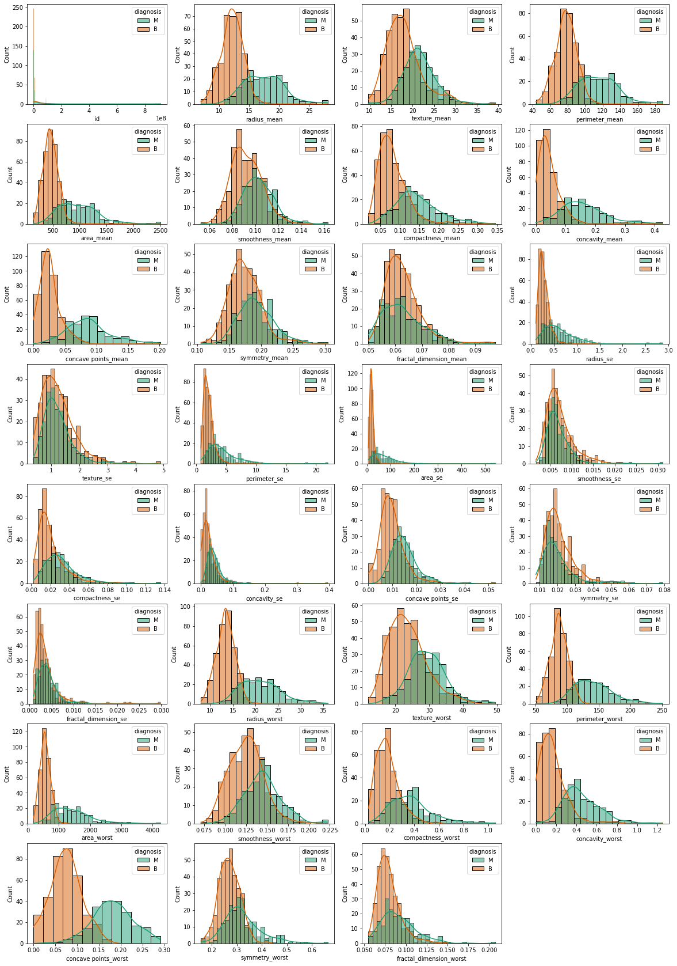

This graph helps to check which of the parameters are normally distributed and which are skewed distributed.

Heatmap:  
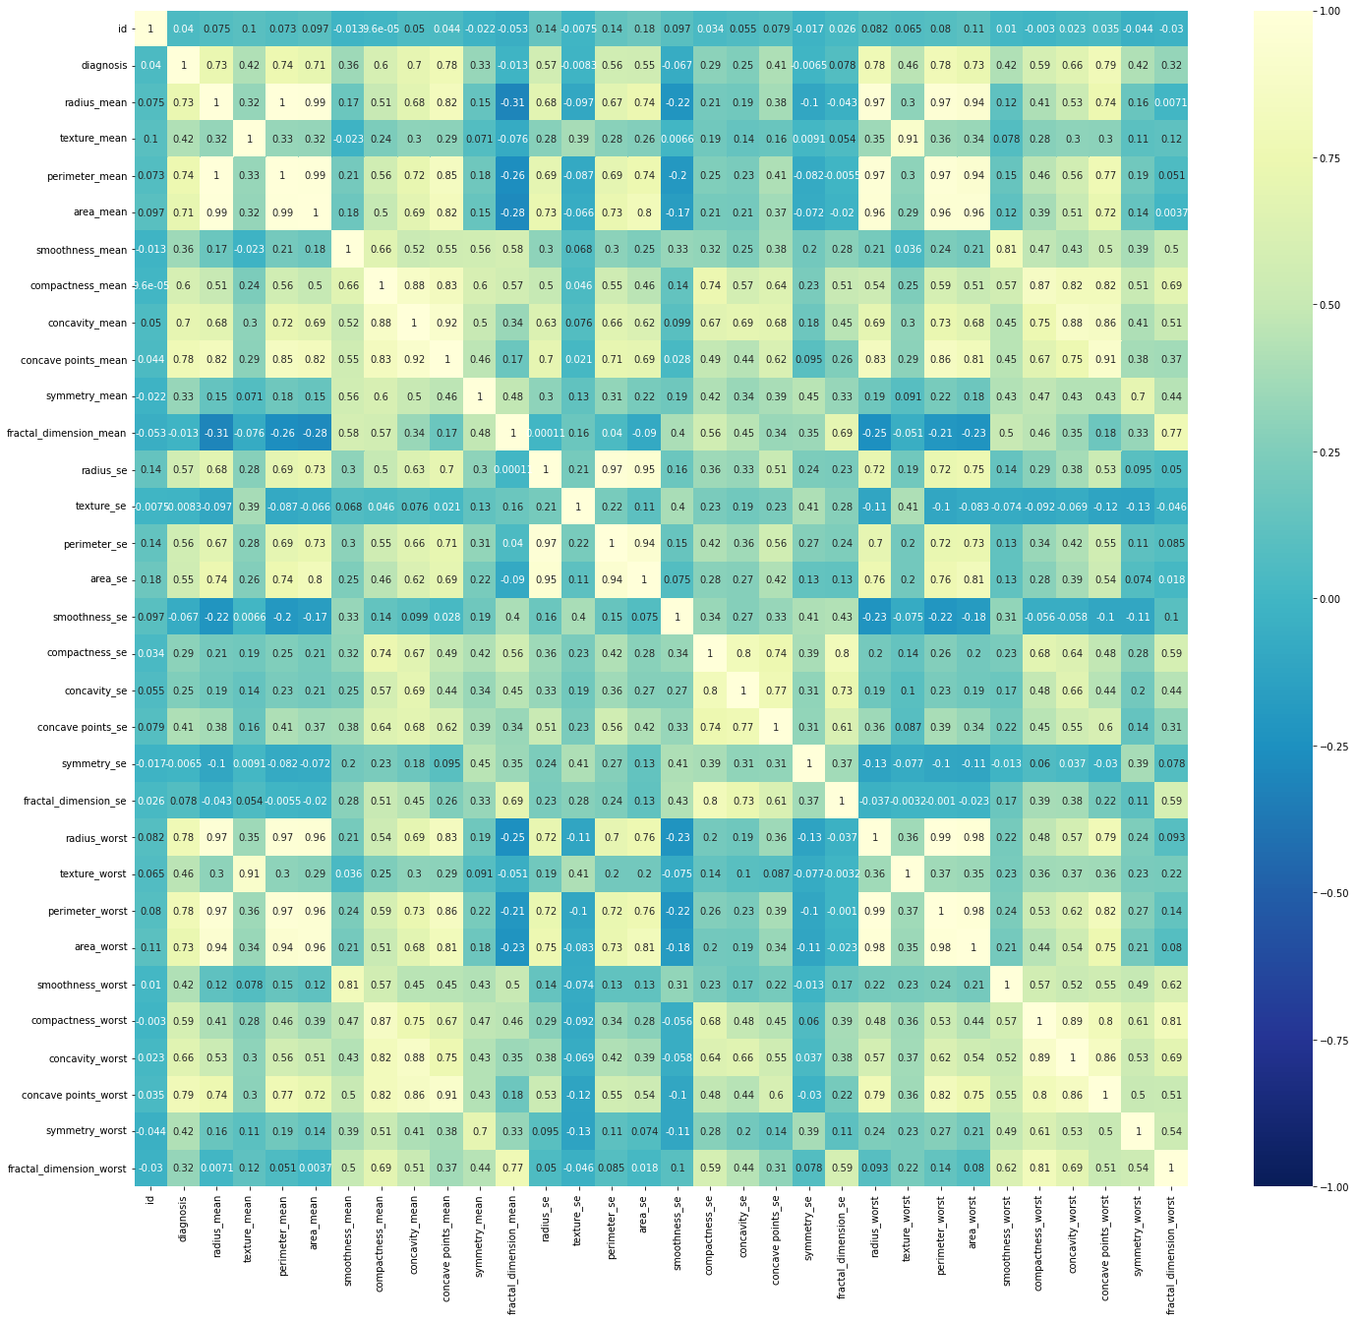

* + Correlation: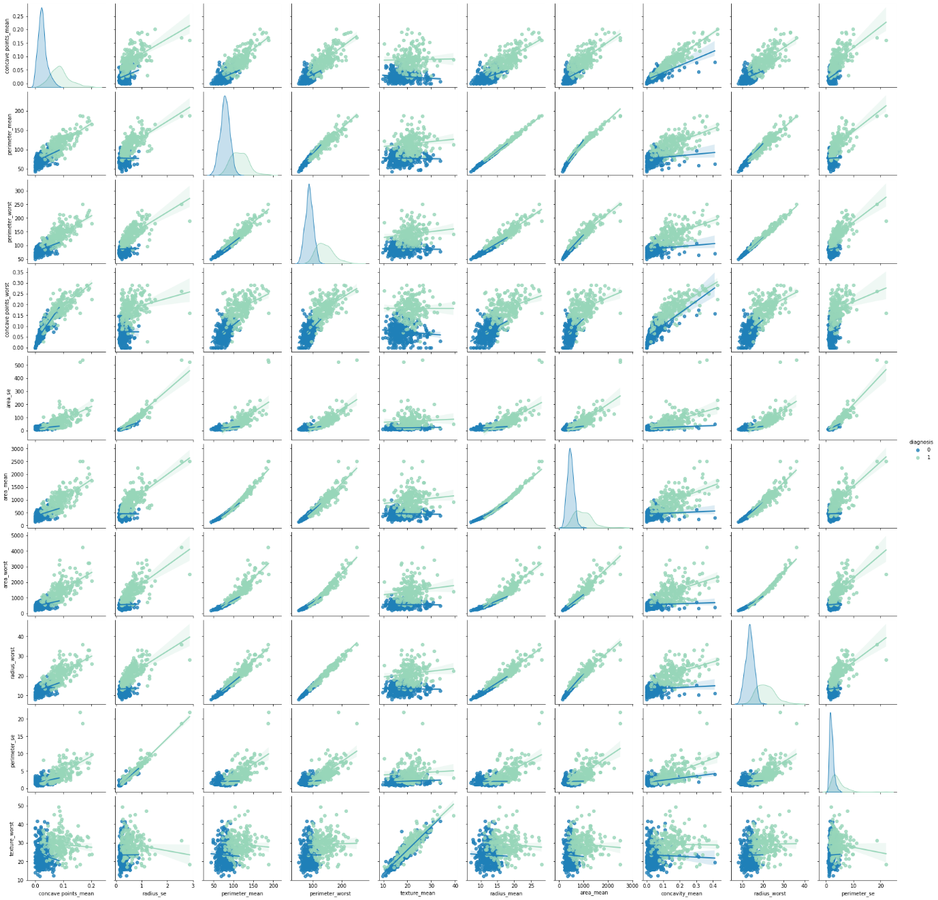
  + The correlation gives dependence between parameters. So, this helps in performing feature engineering.
  + [Google Collab link](https://colab.research.google.com/drive/12XEtj5SYwWTyFbtKGeiI4bBoaPnCyNAe#scrollTo=Nsr_9kRH68LQ)

1. **Tasks to be performed in the upcoming week.**

* We will try to perform a linear regression (a supervised form of learning) on our dataset.